AI STUDY BUDDY

TEAM MEMBERS:

- TEAM ID: SWTID-2026-2904
- Arthi.S: arthi01102006@gmail.com
- A.K.Kokilavani : kokianbu25@gmail.com
- Kanchana priya.S :priyadhachu18@gmail.com
- Logeshwari. A: loguathikesavan@gmail.com
- Ishwarya.R: ishwaryashanthi20@gmail.com

ABSTRACT
AI Study Buddy is an intelligent educational support system designed to help students learn, revise, and understand academic subjects more effectively. The system uses Artificial Intelligence to provide personalized study assistance based on the student’s learning needs. It can provide topic-wise questions, answers, explanations, summaries, and revision support.
The main purpose of the project is to make studying easier, more interactive, and organized. Instead of depending only on textbooks or searching through different websites, students can use the AI Study Buddy as a single platform for their learning activities. The system can help students identify important topics, practice questions, and improve their understanding.
AI Study Buddy can be useful for students during regular studies as well as examination preparation. It provides quick learning assistance and encourages students to study independently. The project demonstrates how Artificial Intelligence can be used to create a simple and personalized educational environment.

INTRODUCTION
Education is an important part of a student's personal and professional development. Students often need additional support while learning difficult topics, preparing for examinations, and revising lessons. Traditional learning methods mainly depend on textbooks, classroom teaching, notes, and external study materials. Finding the right information from these sources can sometimes take considerable time.
Artificial Intelligence provides new opportunities to improve the learning experience. An AI-based study assistant can understand a student's questions and provide relevant explanations and practice materials. It can also support different learning activities such as question answering, topic-based learning, revision, and self-assessment.
The AI Study Buddy project is developed as a digital learning assistant that supports students in their academic activities. It aims to provide an easy-to-use learning environment where students can interact with the system and receive study-related assistance.

PROBLEM STATEMENT
Students commonly face difficulties in understanding complex academic topics and finding suitable study materials. They may need to search multiple sources to find explanations, questions, summaries, and revision materials.
Traditional study methods may not provide personalized assistance for every student. Students also have different learning speeds and different levels of understanding. Therefore, there is a need for a system that can provide quick and personalized study support.
The AI Study Buddy addresses this problem by providing an AI-based platform that can assist students with academic questions, topic-wise learning, revision, and practice.

OBJECTIVES OF THE PROJECT
The main objectives of the AI Study Buddy project are:
- To develop an AI-based educational assistance system.
- To provide students with quick answers to study-related questions.
- To provide topic-wise questions and learning materials.
- To help students understand difficult concepts through simple explanations.
- To support examination preparation and revision.
- To provide an interactive learning environment.
- To reduce the time required to search for study information.
- To encourage self-learning and independent study.
- To provide personalized assistance based on student requirements.

EXISTING SYSTEM
In the existing system, students mainly depend on textbooks, classroom notes, teachers, educational websites, and search engines for their studies. When students have doubts, they may need to search through multiple sources to find appropriate answers.
Most traditional learning resources do not provide personalized interaction. Students may receive general information rather than explanations based on their specific questions or learning requirements.
Another limitation is that study materials such as questions, explanations, and revision notes are often available separately. Students need to switch between different resources to complete their preparation. This can make the learning process less convenient.

PROPOSED SYSTEM
The proposed system is AI Study Buddy, an intelligent study assistance platform that provides students with academic support through Artificial Intelligence.
Students can enter a question or select a topic, and the system processes the input and provides a suitable response. The system can support activities such as topic-wise questions, explanations, summaries, revision, and practice.
The proposed system provides a centralized learning environment where students can interact with the AI Study Buddy whenever they need assistance. It aims to make learning more convenient, interactive, and student-friendly.

SYSTEM ARCHITECTURE
The system architecture represents the major components of the AI Study Buddy and their interaction.
Basic Architecture:
STUDENT
|
↓
USER INTERFACE
|
↓
INPUT PROCESSING
|
↓
AI ENGINE
|
┌────────┼────────┐
↓ ↓ ↓
Question Topic Learning
Answering Module Support
| | |
└────────┼────────┘
↓
RESPONSE GENERATION
|
↓
STUDENT OUTPUT
The student interacts with the system through the user interface. The input is processed and sent to the AI engine. The AI engine analyzes the request and generates an appropriate response. The response is then displayed to the student.

SYSTEM WORKFLOW
The workflow of the AI Study Buddy consists of the following steps:
- The student opens the AI Study Buddy application.
- The student enters a question or selects a topic.
- The system receives the student's input.
- The input is processed by the system.
- The AI engine analyzes the request.
- Relevant information or a suitable response is generated.
- The generated response is displayed to the student.
- The student can ask another question or continue learning.
- The student can use the system for revision and practice.
Workflow:
Start
↓
Open AI Study Buddy
↓
Enter Question / Select Topic
↓
Process Input
↓
AI Analysis
↓
Generate Response
↓
Display Answer
↓
Continue Learning?
↓
Yes → Ask Another Question
|
No
↓
End

MODULES OF THE SYSTEM

User Module
This module allows students to interact with the AI Study Buddy. Students can enter questions, select topics, and receive responses.

Topic Selection Module
This module allows students to select a particular subject or topic. Based on the selected topic, the system can provide relevant learning support.

Question and Answer Module
This is one of the main modules of the system. Students can ask academic questions and receive AI-generated answers and explanations.

Topic-Wise Question Module
This module provides questions based on selected topics. It can be used for practice and examination preparation.

Explanation Module
This module provides simple explanations for difficult concepts. It helps students understand topics more clearly.

Revision Module
The revision module helps students review previously studied topics and important concepts.

Result/Feedback Module
This module can provide feedback based on the student's practice activities and responses.

FUNCTIONAL REQUIREMENTS
The functional requirements describe what the system should be able to perform.
- The system should allow students to enter questions.
- The system should process student inputs.
- The system should generate relevant responses.
- The system should provide topic-wise learning support.
- The system should provide topic-wise questions.
- The system should provide explanations for academic concepts.
- The system should support revision activities.
- The system should display responses clearly.
- The system should allow students to continue asking questions.
- The system should provide an interactive learning experience.

SOFTWARE REQUIREMENTS

Operating System
- Windows 10/11 or later
- Linux or other supported operating systems

Development Environment
- Visual Studio Code / suitable IDE
- Web browser

Database
- MySQL / MongoDB or another suitable database

Other Software
- HTML
- CSS
- JavaScript
- AI/API integration
- Web browser

TECHNOLOGIES USED
The following technologies can be used for developing the AI Study Buddy:

Frontend
- HTML
- CSS
- JavaScript

Backend
- Python / suitable backend technology

Database
- MySQL / MongoDB

Artificial Intelligence
- Natural Language Processing
- AI-based response generation
- AI API integration

Development Tools
- Visual Studio Code
- Web Browser

DATA FLOW
The data flow describes how information moves through the AI Study Buddy system.

Student
|
↓
Enter Question / Topic
|
↓
User Interface
|
↓
Input Processing
|
↓
AI Processing
|
↓
Response Generation
|
↓
Display Response
|
↓
Student
The student provides input through the user interface. The system processes the input and sends it to the AI component. The AI component analyzes the request and generates an appropriate response. The response is then returned to the user interface and displayed to the student.

ADVANTAGES
The major advantages of AI Study Buddy are:
- Provides quick study assistance.
- Makes learning more interactive.
- Helps students understand difficult topics.
- Provides topic-wise questions.
- Supports examination preparation.
- Reduces the time required to search for information.
- Encourages self-learning.
- Can be accessed whenever required.
- Provides personalized learning assistance.
- AI-generated responses may sometimes contain incorrect information.
- The system depends on the quality of the input provided by the student.
- Internet connectivity may be required for some AI services.
- AI services may have usage limitations.Combines multiple learning activities in one platform.

LIMITATIONS
Although AI Study Buddy provides several benefits, it has some limitations:
- AI-generated responses may sometimes contain incorrect information.
- The system depends on the quality of the input provided by the student.
- Internet connectivity may be required for some AI services.
- AI services may have usage limitations.
- The system cannot completely replace teachers or classroom learning.
- Advanced AI features may require additional resources.
- The quality of responses may depend on the AI model being used.

APPLICATIONS
AI Study Buddy can be used in various educational situations:
- School education
- College education
- Examination preparation
- Self-learning
- Assignment assistance
- Topic revision
- Practice question generation
- Doubt clarification
- Academic revision
- Online learning platforms
It can be particularly useful for students who want quick assistance while studying independently.

FUTURE ENHANCEMENT
The AI Study Buddy can be enhanced with several additional features in the future.
A personalized learning system can be developed to understand the student's learning progress and recommend suitable topics. A voice-based learning feature can also be added so that students can ask questions using voice input.
The system can also include quiz generation, automatic evaluation, progress tracking, study reminders, and personalized study plans. A mobile application can be developed to make the system accessible through smartphones.
In the future, multilingual support can be added so students can interact with the AI Study Buddy in different languages. Integration with educational resources and learning management systems can also improve the functionality of the application.

EXPECTED RESULT
The expected result of the project is an AI-based study assistance system that provides students with a simple and interactive learning environment.
The system is expected to provide relevant answers to academic questions, topic-wise questions, explanations, and revision support. It should reduce the effort required to search for learning resources and help students study more independently.
Overall, the AI Study Buddy is expected to demonstrate how Artificial Intelligence can be applied to support students and improve their learning experience.

CONCLUSION
The AI Study Buddy project provides an intelligent and interactive approach to academic learning. It is designed to assist students with questions, explanations, topic-wise practice, and revision activities.
The project demonstrates the usefulness of Artificial Intelligence in the education sector. By bringing different study-support features into one platform, the system can make learning more convenient and accessible.
In conclusion, AI Study Buddy can serve as a useful digital learning companion for students. With further development, features such as personalized learning, voice interaction, progress tracking, quizzes, and multilingual support can make the system more effective and user-friendly.
OUTPUT SCREENSHOT:
USER REGISTER:
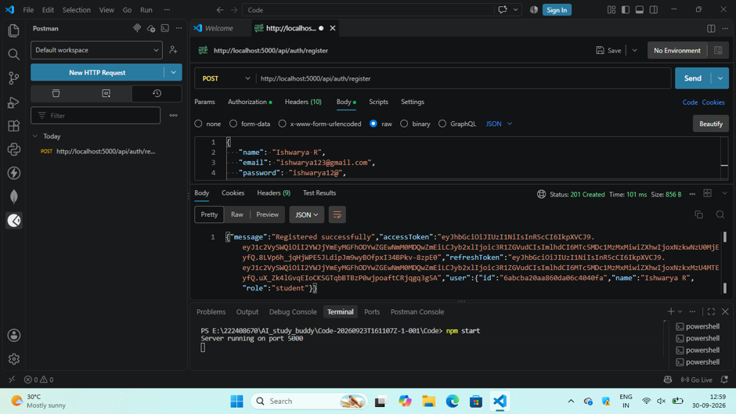
USER LOGIN:
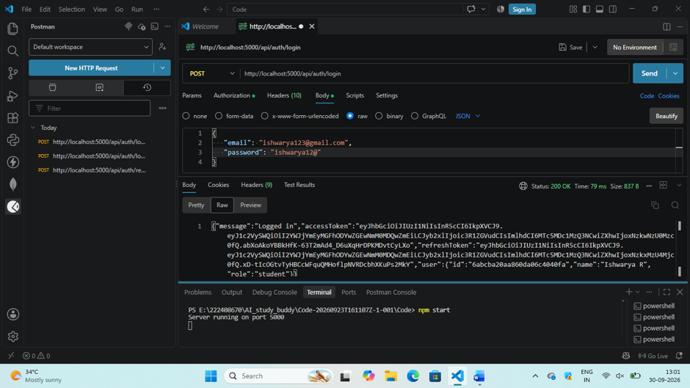

MATERIAL UPLOAD:
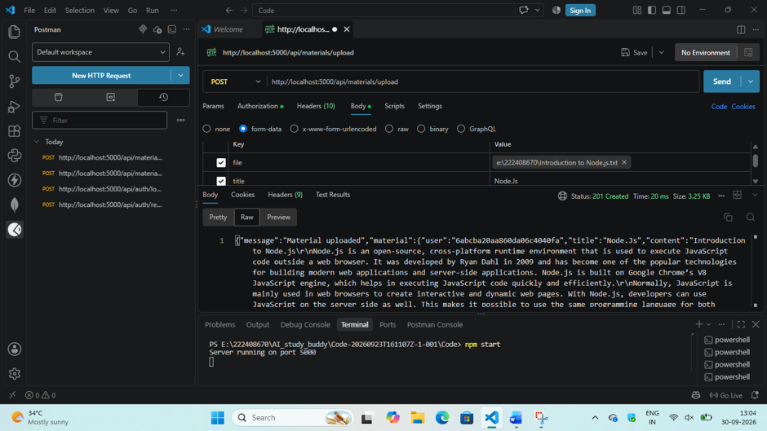
FLASHCARDS:
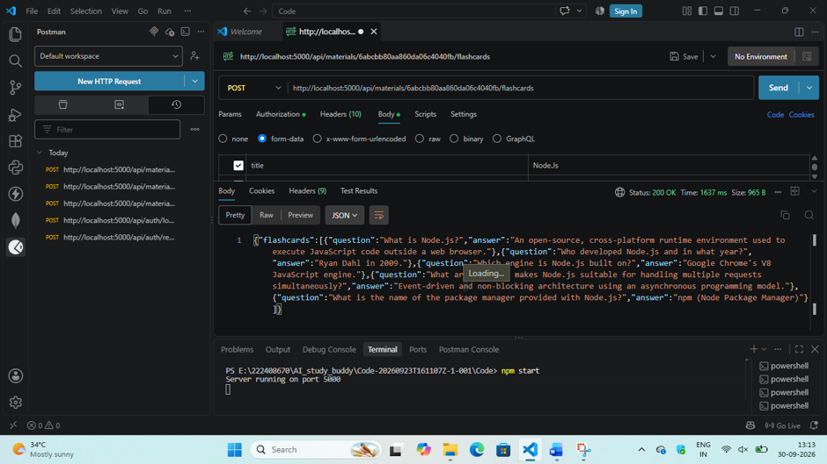
QUIZ:
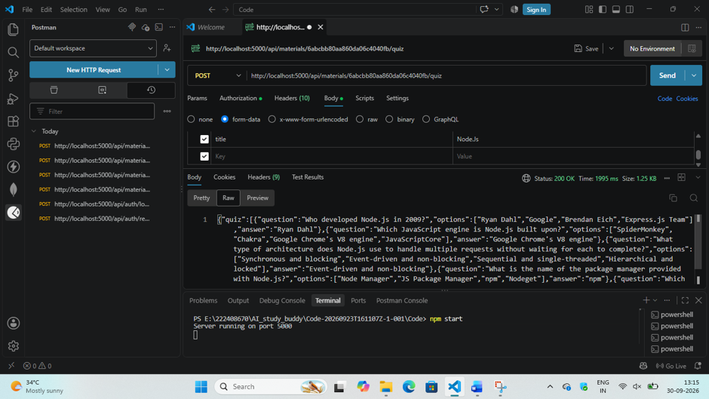
SUMMARIZE:
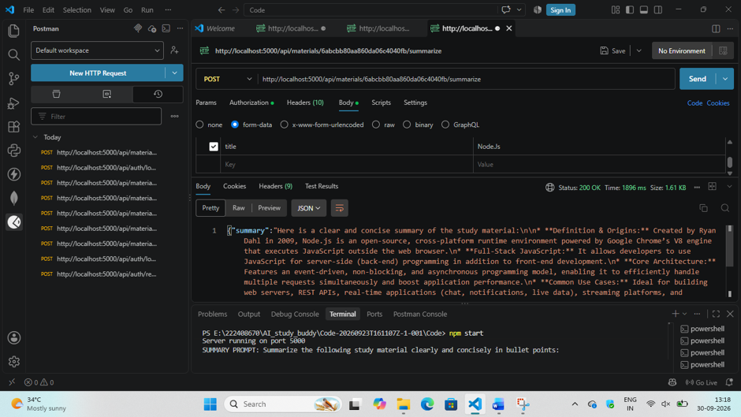
STUDY-PLAN:
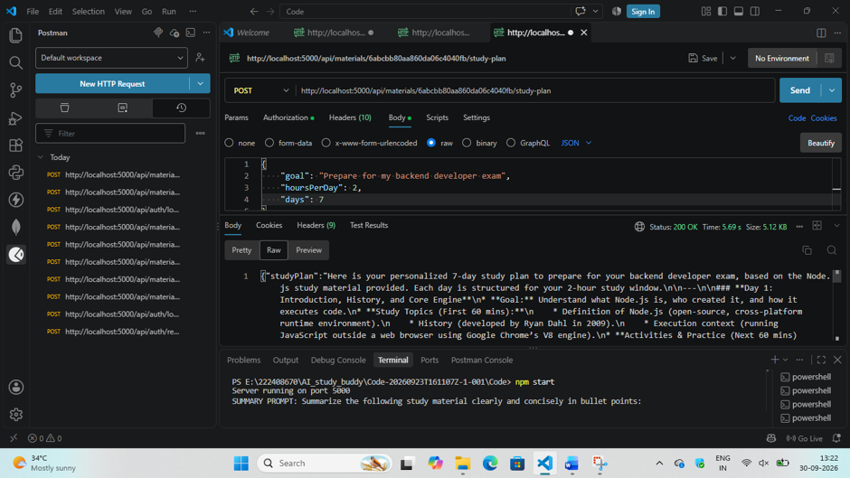
ADMIN REGISTER:
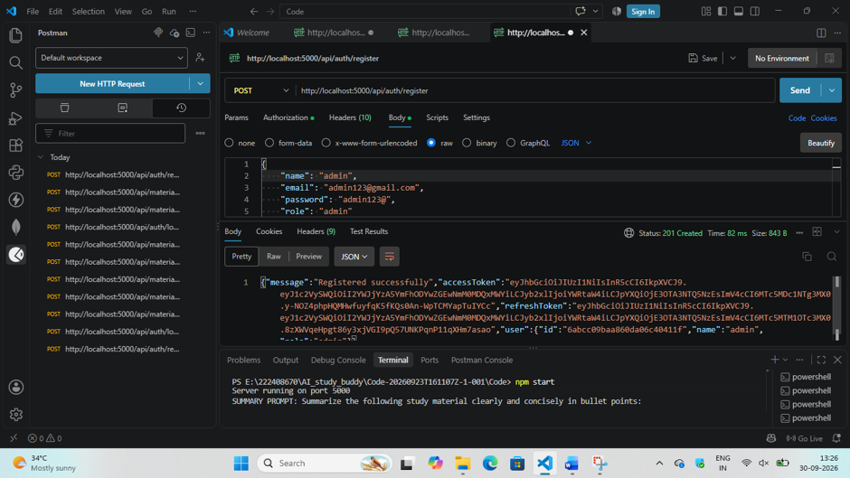
ADMIN LOGIN:
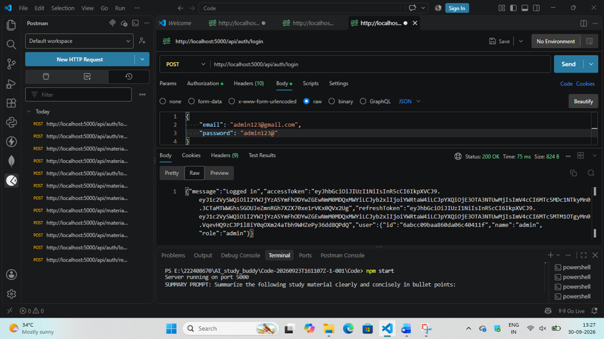
GET USERS:
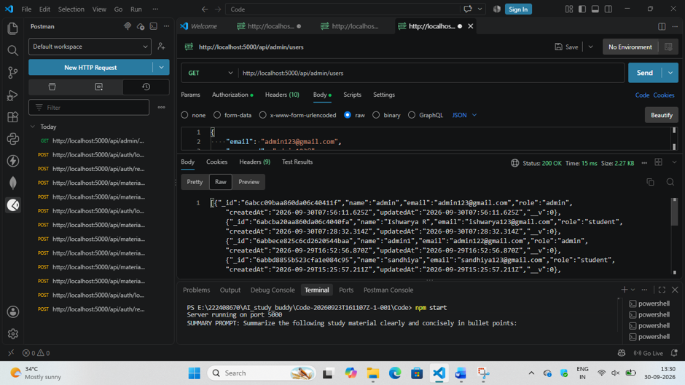
DELETE USER:
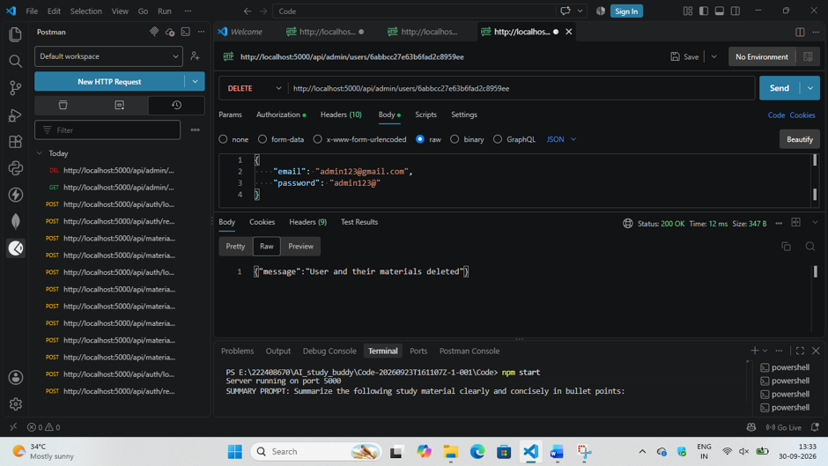
USERS LIST:
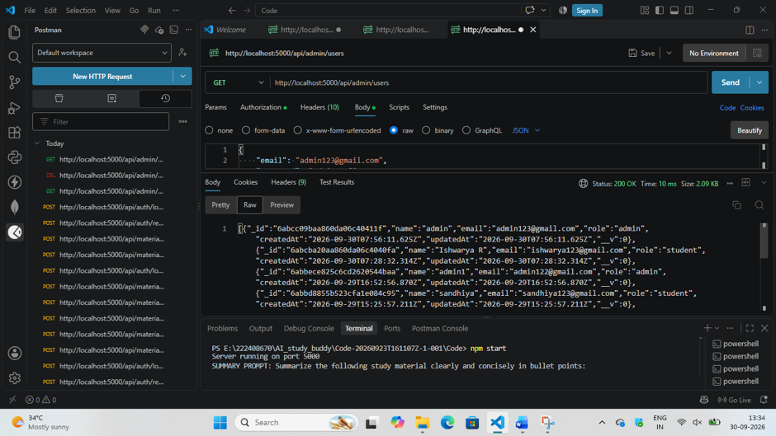
DEMO VIDEO:
https://drive.google.com/file/d/16UN6a5JEG4s5Vsfpc3ztk-JmngoKtHsi/view?usp=drivesdk

